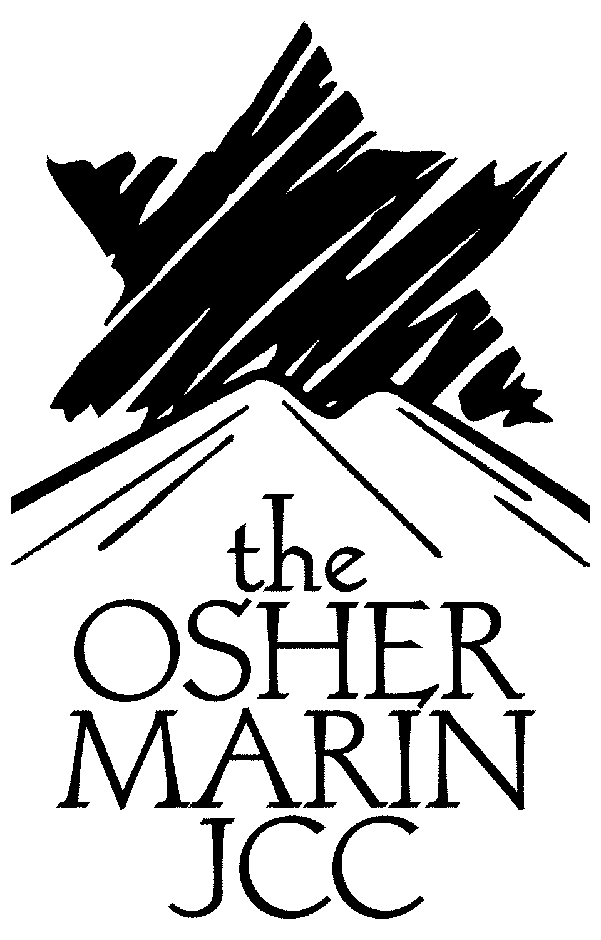
Contact: Joanne Greene
415.444.8066; jgreene@marinjcc.org
FOR IMMEDIATE RELEASE –
Osher Marin JCC Exhibits Work of Three Jewish Rock Photographers in “Rock of Our Ages”

From the 1960’s to the present, Jewish artists have been prominent among those capturing images of rock performers. On Sunday, October 3, 2010, from 4-6pm, the Center for Jewish Life at the Osher Marin JCC will host an opening reception for Rock of Our Ages, an unprecedented rock photography exhibit featuring the work of Bob Minkin < http://www.minkindesign.com/photo/> , Richard Pechner < http://www.rpechner.com/>, and the late Bruce Steinberg < http://www.brucesteinberggallery.com/>. The Marin History Museum Music Center, opening the Marin Rocks exhibit in San Rafael this November, is co-sponsoring this family-oriented opening celebration.

Bob Minkin’s photos have appeared in countless music CDs, DVDs, albums, calendars, books and magazines including Time, Rolling Stone, and Entertainment Weekly. He has photographed over 300 musical artists and groups and is a partner in Minkin Design.

Richard Pechner’s first published rock photos appeared in the book The Hippies published in 1967. He worked with the Grateful Dead in the late 60’s to early 70’s and his most recent assignment was an ad campaign for McIntosh Labs featuring Bob Weir.

Bruce Steinberg entered Cornell’s engineering program at age 16 and subsequently worked for NASA on the Apollo Project. His passion for rock photography soon eclipsed his engineering career. After shooting a series with Janis Joplin, Warner signed him as photographer and album cover designer. His impressive list of album credits includes Tower of Power, Azteca, Santana, Doobie Brothers, Jefferson Starship and many others. He died in 2007 and his daughter, Jenny Roth, is generously sharing his work with us.

The opening celebration of Rock of Our Ages will feature a live acoustic performance by members of Lansdale Station, activities for children, refreshments, and a talk by rock photographer Bob Minkin.

The Rock of Our Ages exhibit will be on display at the Osher Marin JCC, 200 North San Pedro Avenue, San Rafael, through January 18, 2011. Admission to the gallery and the opening reception are free and the public is invited.

The Center for Jewish Life, funded by the Koret Foundation and the Taube Foundation for Jewish Life, is dedicated to providing a range of adult Jewish learning opportunities to the greater North Bay community.

###
Osher Marin Jewish Community Center * www.marinjcc.org
200 N. San Pedro Rd. * San Rafael, CA * 94403 * t 415.444.8081/ f 415.491.1235

